Okehampton Library
What is available from your local library?

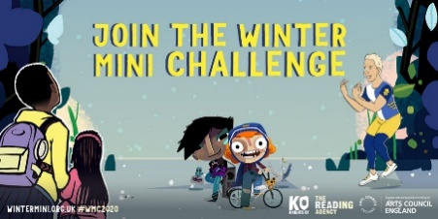
Mini Winter Reading Challenge www.wintermini.org.uk
1 December and 15 January. Sounds great! How do I take part?
Children simply read three or more books - these can be any books of their choice. Every time they finish a book, they add it to their Challenge website profile and leave a short book review.
Reaching their online reading goal will unlock a virtual badge and a special Everyone Is A Hero certificate to print off and keep!

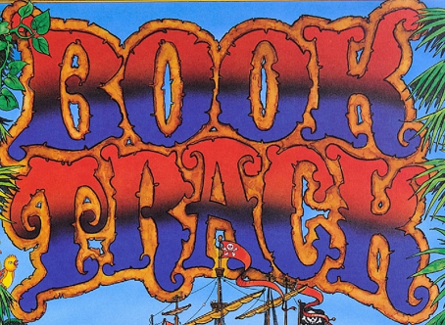
Book Track is a reading scheme for children aged 6 and over to support them in developing a love of reading and confidence in reading.
What about reading 100 books? Are you up for this challenge?
Then, start reading any books of your choice, collect your personal folder from Okehampton Library. You will be able to collect badges and stickers as you go along. To use Book Track online use this link. https://www.devonlibraries.org.uk/web/arena/children-booktrack
If you do not have online access, please visit the library. Reading is fun! Enjoy!

*FREE BOOK* - My Pet Star by Corrinne Averiss
We have copies of ‘My Pet Star’ which The Book Trust have produced to give away to families with children under the age of 5. Collect your copy from Okehampton Library together with a rhyme sheet and activity sheet.

Surprise Reads - Support your local library service and have a little festive fun with our seasonal wrapped surprise book sale!
Picture & Junior Books (contains 2 books), Board Books (contains 3 books) - 50p
Adult Books - £1

Browse our shelves – for some Christmas reads, DVDs, or audio books. We have special themed picture book bags for children to borrow, with FREE activity sheets inside.
DVDs can currently be hired for 10 weeks, for only one week’s hire charge!

Free computer access - booking advisable
Okehampton Library opening hours:
Monday 10:00-12:00 & 14:00-16:00
Tuesday 10:00-12:00 & 14:00-16:00
Wednesday 10:00-12:00
Thursday 10:00-12:00 & 14:00-16:00
Friday 10:00-12:00 & 14:00-16:00
Saturday 10:00-12:00

Closed over Christmas: 24 (from 12 noon) - 30 December and 1 January
Join the library – it’s free https://www.devonlibraries.org.uk/web/arena
Our online library is open 24/7 giving you access to eBooks, eAudio books, eMagazines and much more.

Contact us: Okehampton Library,4 North Street, EX20 1AR
okehampton.library@librariesunlimited.org.uk 01837 52805
Check us out on Facebook, Instagram or Twitter

