**Okehampton Library**

**The Secret Book Quest**

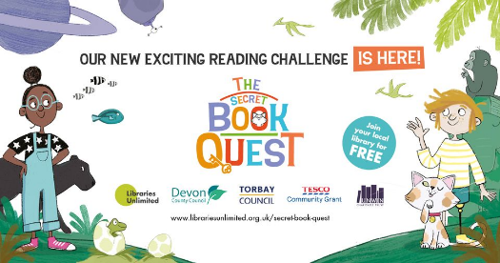

The Secret Book Quest is an exciting new reading challenge for children ages 5 and up.

Read a total of 50 books to collect all the stickers, decipher the code, and win a special prize.

Get a certificate when you reach halfway (25 books) and another when you finish (50 books), along with a finisher’s prize.

How to take part! Sign up for FREE, simply visit your local library and speak to a member of staff.

You will receive your very own Secret Book Quest journal and the first sticker in your collection.

Then browse the library to find your first book, and begin the quest!

**Events**

**Christmas Crafts & Stories ~ Thursday 9th December, 10:30-11:30**

Join us for a festive craft and story. Suitable for children under 5 and their parents/carers.

Free event, donations welcome.

**Christmas Craft Table for children ~ Monday 13th - Saturday 18th December**

Call in any time during our opening hours to get creative at our festive craft table, suitable for children 5+ and their parents/carers. Free activity, donations welcome.

**Seasonal Surprise Book Sale**

Have a little festive fun with our surprise book sale, available throughout December.

Adult books £1, Junior (containing 2 or more books) 50p

**Festive Fundraiser ~ Give the Gift of Reading**

Help us make a lasting impact on children this Christmas. Add a light or star to our glittering online Christmas tree, send a special message to a loved one, and help fund vital services. Visit [www.devonlibraries.org.uk](http://www.devonlibraries.org.uk) and click the link on our homepage.

**Regular events**

**Adults**

**Every Tuesday 13:30-14:30– Knit & Natter**

Bring along your knitting, stitching, crochet or other portable project, for a chat with

like-minded crafters. Knit and Natter takes place in the children’s area of the library. A small selection of baby toys will be available during these sessions.

**Children and Young People**

**Tuesdays 10:00-10:20 & 11:00-11:20** **-** **Bounce & Rhyme**

For under 5s and their carers

Free – booking in advance essential

**Wednesdays 09:30–10:15** **- Duplo Builders & Storytime for ages 0-5**

Free - no booking necessary

**Saturdays 10:30–11:30** **Lego Builders for ages 5+**

Free - no booking necessary

**The Secret Book Quest**

A completely FREE year-round reading challenge for 5-12 year olds across Devon. To take part, children need to sign up, read 50 books, collect stickers and solve the code.

**Children under 8 must be accompanied to all events by a responsible adult**

Please see our library website or Facebook page for any additional events and library services [www.devonlibraries.org.uk](http://www.devonlibraries.org.uk)

**Opening Hours Christmas & New Year opening hours**

**Monday** **09:00-17:00 Friday 24th - 28th Dec**   **Closed**

**Tuesday** **09:00-18:00 Saturday 1st - Monday 3rd Jan**  **Closed**

**Wednesday 09:00-13:00**

**Thursday 09:00-17:00**

**Friday 09:00-18:00**

**Saturday** **09:00-13:00**

**Devon Libraries is part of Libraries Unlimited**

Libraries Unlimited is a registered charity. Every penny raised goes directly towards library services that help make a difference to people’s lives and communities.

To donate, please visit [librariesunlimited.org.uk](https://librariesunlimited.org.uk/)



**Okehampton Library, 4 North Street, Okehampton EX20 1AR**

**01837 52805 okehampton.library@librariesunlimited.org.uk**

